Firmware Design Document
Non-Blocking SPI DMA Driver with FreeRTOS Synchronization
Hardware Target: RP2350 / Raspberry Pi Pico 2
Document Number | ESP-FW-001
Revision | 1.0
Status | RELEASE CANDIDATE — For Test & Production Approval
Date | October 13, 2026
Author | Eric L. Johnson
Organization | Embedded Solutions Provider, LLC
Prepared For | [Client Name]
Classification | Confidential

1. Document Approval
This document must be signed by the responsible parties before firmware is released to the Test phase and subsequently to Production.

Role | Name | Signature | Date
Firmware Author | Eric L. Johnson
Test Lead
Engineering Manager
Release Authority

2. Overview and Purpose
This document describes the design, architecture, and interface of the Non-Blocking SPI DMA Driver (spi_dma_driver) developed for the RP2350 microcontroller platform using the Raspberry Pi Pico SDK and the FreeRTOS real-time operating system.
The purpose of this document is to serve as the authoritative technical reference for:
- Firmware engineering review and code sign-off
- Test team validation planning and test case development
- Production release gate approval
- Ongoing maintenance and future revision baseline

3. Hardware Platform and Dependencies
Microcontroller | RP2350 (Raspberry Pi Pico 2)
SDK | Raspberry Pi Pico SDK (pico/stdlib.h, hardware/spi.h, hardware/dma.h)
RTOS | FreeRTOS (task.h, semphr.h)
SPI Interface | SPI0 hardware peripheral
DMA Controller | RP2350 integrated DMA, IRQ0
Clock Speed | 1 MHz SPI baudrate (configurable)
GPIO Pins | SCK: GP2, TX/MOSI: GP3, RX/MISO: GP4, CS: GP5
Transfer Width | 8-bit (DMA_SIZE_8)

4. Architecture and Design Description

4.1 Design Philosophy
The driver implements a non-blocking, full-duplex SPI transfer mechanism using the RP2350 DMA controller. Rather than polling for transfer completion (which wastes CPU cycles) or using blocking delays, the driver uses a FreeRTOS binary semaphore to yield the calling task during the transfer and resume it when the DMA interrupt fires. This allows other RTOS tasks to execute during long SPI transfers.

4.2 Component Overview
File | Description
spi_dma_driver.h | Public API header — configuration structure, status codes, function declarations
spi_dma_driver.c | Driver implementation — init, DMA config, ISR, transfer control
main.c | Test application — FreeRTOS task demonstrating driver usage

4.3 Full System Sequence Diagram
Figure 1 shows the complete interaction between the FreeRTOS task, the driver API, the DMA controller, the interrupt service routine, and the binary semaphore during a single SPI transfer.

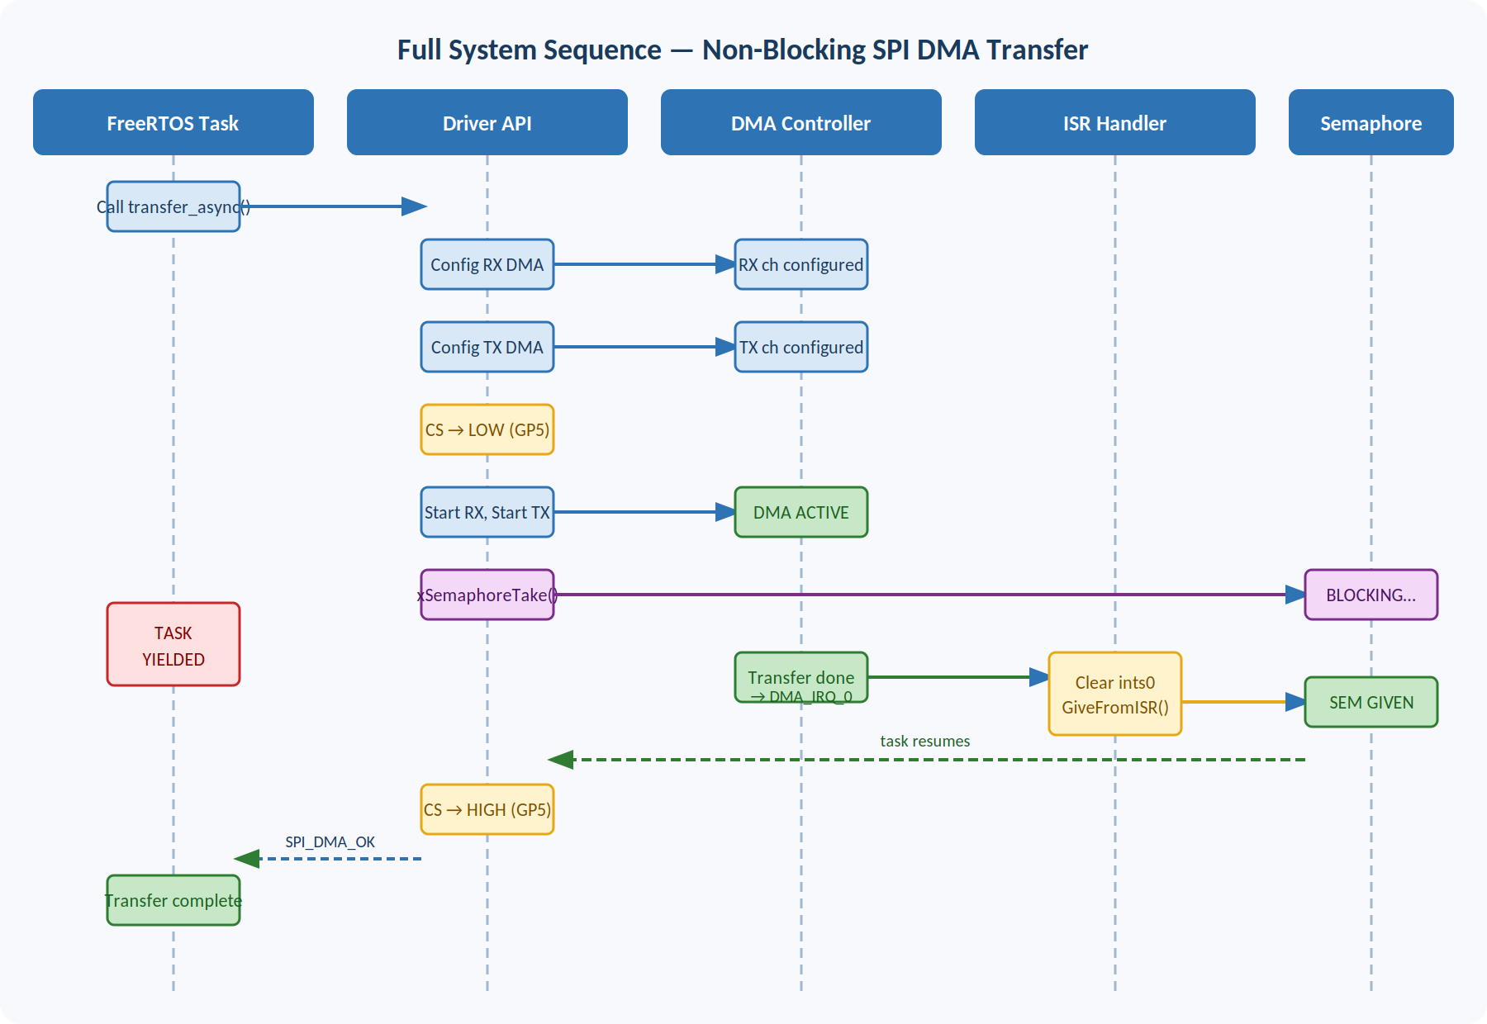
Figure 1 — Full System Sequence: FreeRTOS Task → Driver API → DMA → ISR → Semaphore

4.4 Transfer Sequence (Narrative)
The following sequence describes a single spi_dma_transfer_async() call from initiation to completion:
- 1. Caller provides TX buffer, RX buffer, length, and timeout in milliseconds.
- 2. Driver configures RX DMA channel: source = SPI DR register, destination = rx_buf, increment write pointer.
- 3. Driver configures TX DMA channel: source = tx_buf, destination = SPI DR register, increment read pointer.
- 4. Chip Select (GP5) is asserted LOW to begin the SPI transaction.
- 5. RX DMA channel is started first, then TX DMA channel (ensures no data is missed).
- 6. Calling FreeRTOS task blocks on xSemaphoreTake() with the specified timeout.
- 7. On RX DMA completion, spi_dma_isr() fires, clears DMA_IRQ_0, and calls xSemaphoreGiveFromISR().
- 8. Blocked task resumes; Chip Select is de-asserted HIGH; function returns SPI_DMA_OK.
- 9. On timeout, Chip Select is de-asserted and SPI_DMA_ERROR_TIMEOUT is returned.

4.5 DMA Channel Configuration Flow
Figure 2 shows the step-by-step logic inside spi_dma_transfer_async() for configuring both DMA channels before the transfer begins.

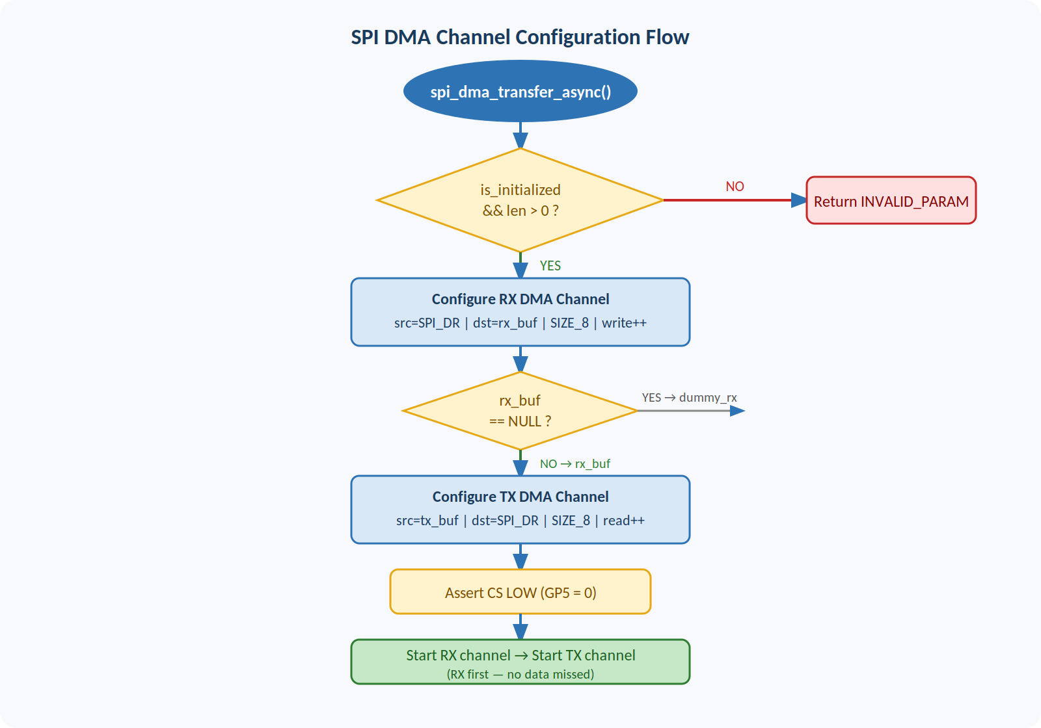
Figure 2 — DMA Channel Configuration Flow (spi_dma_transfer_async entry path)

4.6 Interrupt Service Routine
The ISR (spi_dma_isr) is registered as an exclusive handler on DMA_IRQ_0. It performs three operations:
- Clears the RX DMA channel interrupt flag in dma_hw->ints0.
- Releases the binary semaphore via xSemaphoreGiveFromISR().
- Triggers a context switch via portYIELD_FROM_ISR() if a higher-priority task was unblocked.

4.7 FreeRTOS Semaphore Block / Unblock Sequence
Figure 3 shows how the FreeRTOS binary semaphore coordinates the task block during the DMA transfer and the unblock triggered by the ISR, including the timeout path.

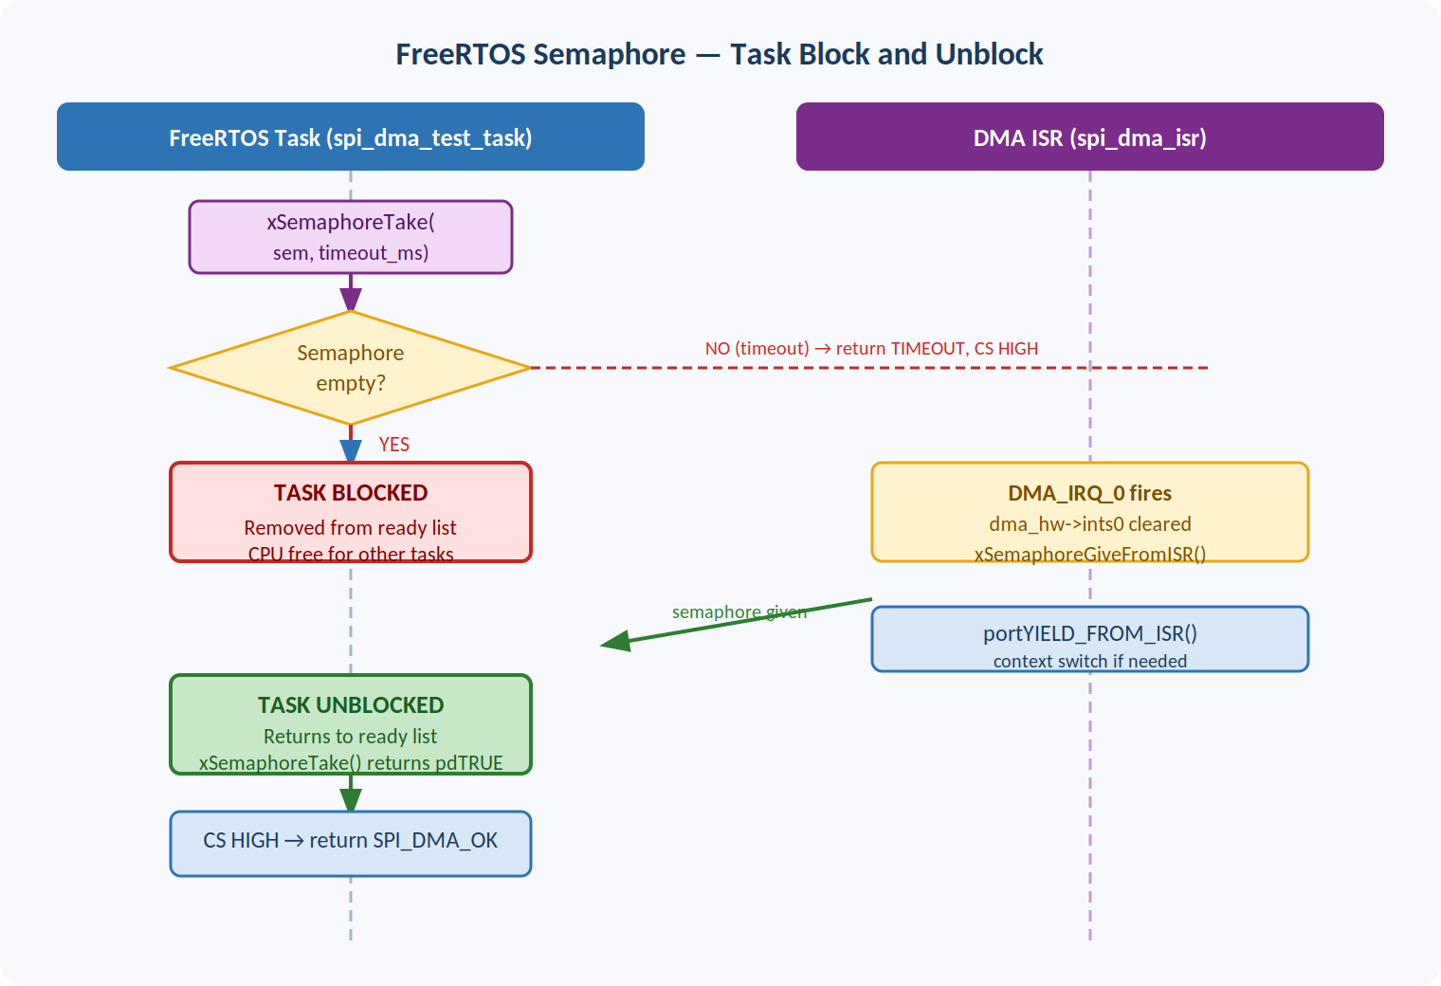
Figure 3 — FreeRTOS Semaphore Block/Unblock: Normal completion and timeout paths

4.8 Null Buffer Support
Both TX and RX buffers are optional. If tx_buf is NULL, a static dummy byte (0xFF) is transmitted. If rx_buf is NULL, received bytes are discarded into a static dummy variable. This supports TX-only and RX-only modes without requiring the caller to allocate unused buffers.

5. API Reference

5.1 Status Codes
Status Code | Description
SPI_DMA_OK | Operation completed successfully
SPI_DMA_ERROR_INVALID_PARAM | NULL pointer or zero-length transfer passed
SPI_DMA_ERROR_BUSY | Driver busy (reserved for future use)
SPI_DMA_ERROR_TIMEOUT | Transfer did not complete within timeout_ms
SPI_DMA_ERROR_HARDWARE | FreeRTOS semaphore creation failed at init

5.2 Configuration Structure — spi_dma_config_t
Field | Description
spi_instance | Pointer to SPI hardware peripheral — spi0 or spi1
baudrate_hz | SPI clock frequency in Hz (e.g., 1000000 for 1 MHz)
pin_sck | GPIO pin number for Serial Clock
pin_tx | GPIO pin number for MOSI (Master Out Slave In)
pin_rx | GPIO pin number for MISO (Master In Slave Out)
pin_cs | GPIO pin number for Chip Select (active LOW)

5.3 spi_dma_init()
spi_dma_status_t spi_dma_init(const spi_dma_config_t *config);

Initializes the SPI peripheral, GPIO pins, DMA channels, FreeRTOS semaphore, and DMA interrupt handler. Must be called once before any transfers. Returns SPI_DMA_OK on success.
Parameter | Description
config | Pointer to a populated spi_dma_config_t structure. Must not be NULL.
Returns | SPI_DMA_OK, SPI_DMA_ERROR_INVALID_PARAM, or SPI_DMA_ERROR_HARDWARE

5.4 spi_dma_transfer_async()
spi_dma_status_t spi_dma_transfer_async(const uint8_t *tx_buf, uint8_t *rx_buf, size_t len, uint32_t timeout_ms);

Executes a non-blocking full-duplex SPI transfer using DMA. The calling FreeRTOS task yields until the transfer completes or the timeout expires. Must not be called from an ISR context.
Parameter | Description
tx_buf | Pointer to transmit data. Pass NULL for RX-only transfers.
rx_buf | Pointer to receive buffer. Pass NULL for TX-only transfers.
len | Number of bytes to transfer. Must be greater than 0.
timeout_ms | Maximum wait time in milliseconds before returning TIMEOUT.
Returns | SPI_DMA_OK or SPI_DMA_ERROR_TIMEOUT or SPI_DMA_ERROR_INVALID_PARAM

6. Known Limitations and Open Items
Item | Description
Single instance only | The driver uses a single static control block. Only one SPI DMA instance can be active per build.
CS pin hardcoded in transfer | Chip Select (GP5) is referenced by literal value in spi_dma_transfer_async(). Should use config struct value in future revision.
No re-entrancy protection | Concurrent calls to spi_dma_transfer_async() from multiple tasks are not protected. Caller must ensure mutual exclusion.
DMA_ERROR_BUSY not implemented | SPI_DMA_ERROR_BUSY is defined but not returned. Busy detection is a future enhancement.
No deinit function | No spi_dma_deinit() is provided. DMA channels and IRQ handler persist until system reset.

7. Test Criteria and Pass/Fail Conditions
The following tests must pass before firmware is approved for production release. The Test Lead is responsible for executing and documenting each test result.

ID | Test Case | Pass Condition | Result
T01 | Driver Initialization | spi_dma_init() returns SPI_DMA_OK with valid config
T02 | Null Config Rejection | spi_dma_init(NULL) returns SPI_DMA_ERROR_INVALID_PARAM
T03 | Full-Duplex Transfer | 64-byte TX pattern received correctly on RX loopback
T04 | TX-Only Transfer | tx_buf valid, rx_buf NULL — completes without fault
T05 | RX-Only Transfer | tx_buf NULL, rx_buf valid — completes without fault
T06 | Timeout Detection | Transfer with no slave returns SPI_DMA_ERROR_TIMEOUT
T07 | CS Assertion Timing | CS asserted LOW before first byte, HIGH after last byte (scope verify)
T08 | FreeRTOS Task Yield | Other tasks execute during transfer (verified by task log)
T09 | ISR Context Switch | portYIELD_FROM_ISR triggers correct task switch on completion
T10 | Repeat Transfers | 1000 consecutive transfers complete without error or hang

8. Revision History
Revision | Description
1.0 | Initial release — Non-blocking SPI DMA driver with FreeRTOS semaphore synchronization. RP2350 target. Three embedded architecture diagrams added.

9. Release Gate Checklist
The following items must be completed and checked before firmware proceeds through each gate.

9.1 Design Review → Test Gate
- ☐ Design document reviewed and approved by Engineering Manager
- ☐ All Known Limitations in Section 6 reviewed and accepted or assigned
- ☐ Source code reviewed by second firmware engineer
- ☐ All files checked into version control with tag ESP-FW-001-RC1

9.2 Test → Production Gate
- ☐ All T01 through T10 test cases passed and documented
- ☐ Test Lead signature obtained on approval table (Section 1)
- ☐ No open P1 or P2 defects
- ☐ Binary build hash recorded for traceability

9.3 Production → Shipment Gate
- ☐ Release Authority signature obtained on approval table (Section 1)
- ☐ Build artifact archived per company configuration management procedure
- ☐ Customer delivery package prepared and reviewed

